SEC Form 3
FORM 3 | UNITED STATES SECURITIES AND EXCHANGE COMMISSION  Washington, D.C. 20549  INITIAL STATEMENT OF BENEFICIAL OWNERSHIP OF SECURITIES  Filed pursuant to Section 16(a) of the Securities Exchange Act of 1934  or Section 30(h) of the Investment Company Act of 1940
  OMB APPROVAL
  OMB Number: | 3235-0104
  Estimated average burden
  hours per response: | 0.5
1. Name and Address of Reporting Person*  (Street) | 2. Date of Event Requiring Statement (Month/Day/Year)  06/29/2026 | 3. Issuer Name and Ticker or Trading Symbol  Carlyle Group Inc. [ CG ]
  Heinzelman Kate Elizabeth
  (Last) | (First) | (Middle)
  1001 PENNSYLVANIA AVENUE, NW
  WASHINGTON | DC | 20004
  (City) | (State) | (Zip)
 |  | 4. Relationship of Reporting Person(s) to Issuer  (Check all applicable) | 5. If Amendment, Date of Original Filed (Month/Day/Year)
   | Director |  | 10% Owner
   | Officer (give title below) |  | Other (specify below)
  General Counsel
6. Individual or Joint/Group Filing (Check Applicable Line)
Form filed by One Reporting Person
Form filed by More than One Reporting Person

Table I - Non-Derivative Securities Beneficially Owned
1. Title of Security (Instr. 4) | 2. Amount of Securities Beneficially Owned (Instr. 4) | 3. Ownership Form: Direct (D) or Indirect (I) (Instr. 5) | 4. Nature of Indirect Beneficial Ownership (Instr. 5)
Table II - Derivative Securities Beneficially Owned
(e.g., puts, calls, warrants, options, convertible securities)
1. Title of Derivative Security (Instr. 4) | 2. Date Exercisable and Expiration Date (Month/Day/Year) |  | 3. Title and Amount of Securities Underlying Derivative Security (Instr. 4) |  | 4. Conversion or Exercise Price of Derivative Security | 5. Ownership Form: Direct (D) or Indirect (I) (Instr. 5) | 6. Nature of Indirect Beneficial Ownership (Instr. 5)
1. Title of Derivative Security (Instr. 4) | Date Exercisable | Expiration Date | Title | Amount or Number of Shares | 4. Conversion or Exercise Price of Derivative Security | 5. Ownership Form: Direct (D) or Indirect (I) (Instr. 5) | 6. Nature of Indirect Beneficial Ownership (Instr. 5)
Explanation of Responses:
Remarks:
Exhibit 24.1 - Power of Attorney
No securities are beneficially owned.
 | /s/ Anne K. Frederick by power of attorney for Kate E. Heinzelman | 07/08/2026
 | ** Signature of Reporting Person | Date
Reminder: Report on a separate line for each class of securities beneficially owned directly or indirectly.
* If the form is filed by more than one reporting person, see Instruction 5 (b)(v).
** Intentional misstatements or omissions of facts constitute Federal Criminal Violations See 18 U.S.C. 1001 and 15 U.S.C. 78ff(a).
Note: File three copies of this Form, one of which must be manually signed. If space is insufficient, see Instruction 6 for procedure.
Persons who respond to the collection of information contained in this form are not required to respond unless the form displays a currently valid OMB Number.
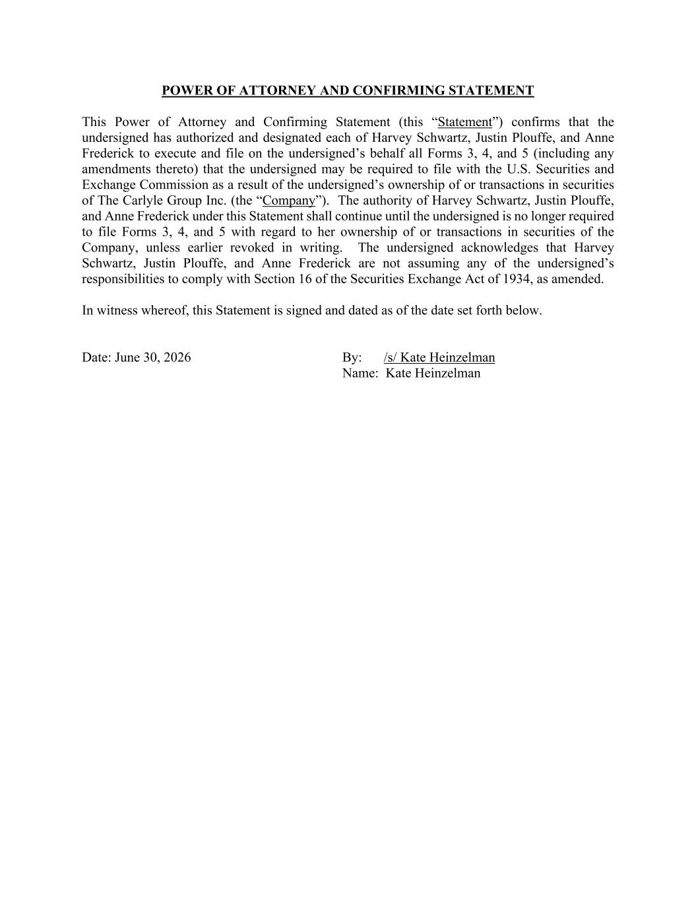
POWER OF ATTORNEY AND CONFIRMING STATEMENT This Power of Attorney and Confirming Statement (this “Statement”) confirms that the undersigned has authorized and designated each of Harvey Schwartz, Justin Plouffe, and Anne Frederick to execute and file on the undersigned’s behalf all Forms 3, 4, and 5 (including any amendments thereto) that the undersigned may be required to file with the U.S. Securities and Exchange Commission as a result of the undersigned’s ownership of or transactions in securities of The Carlyle Group Inc. (the “Company”). The authority of Harvey Schwartz, Justin Plouffe, and Anne Frederick under this Statement shall continue until the undersigned is no longer required to file Forms 3, 4, and 5 with regard to her ownership of or transactions in securities of the Company, unless earlier revoked in writing. The undersigned acknowledges that Harvey Schwartz, Justin Plouffe, and Anne Frederick are not assuming any of the undersigned’s responsibilities to comply with Section 16 of the Securities Exchange Act of 1934, as amended. In witness whereof, this Statement is signed and dated as of the date set forth below. Date: June 30, 2026 By: /s/ Kate Heinzelman Name: Kate Heinzelman

